Node.js, the server-side scripting tool, uses JavaScript – a language that is popular with millions of developers worldwide – ensuring that it has a much lower learning curve even for complete beginners. Using Node.js, one can build everything, starting from a simple command line programs to the complex enterprise level web applications with equal ease. This is why most industries demand a [***Certified Node.js Developer***](https://www.edureka.co/mastering-node-js) to manage the entire server side. Node.js, also brings with it, career opportunities at various levels. In case you are planning to attend Node.js interviews in the near future, we are here to help you with a list of Top 50 Node.js interview questions that you must prepare in 2019.

In this Node.js interview questions article, I have divided the questions into 3 segments based on their difficulty level:

* [Node.js Interview Questions – Beginners Level](https://www.edureka.co/blog/interview-questions/top-node-js-interview-questions-2016/#beginnerslevel)
* [Node.js Interview Questions – Moderate Level](https://www.edureka.co/blog/interview-questions/top-node-js-interview-questions-2016/#moderatelevel)
* [Node.js Interview Questions – Advanced Level](https://www.edureka.co/blog/interview-questions/top-node-js-interview-questions-2016/#advancedlevel)

Before I start off with this Node.js Interview Questions article, let me put forth a request to the readers who might have attended Node.js interviews in recent past. So, if you have come across such questions which were asked in interviews but are missing in this article, feel free to put those questions in the comment section below. We will try and answer those at the earliest so that others can also benefit from it.

Now, let’s get started.

**Node.js Interview Questions – Beginners Level**

**1. Differentiate between JavaScript and Node.js.**

|  |  |  |
| --- | --- | --- |
| ***Features*** | **JavaScript** | **Node.js** |
| *Type* | Programming Language | Interpreter and environment for JavaScript |
| *Utility* | Used for any client-side activity for a web application | Used for accessing or performing any non-blocking operation of any operating system |
| *Running Engine* | Spider monkey (FireFox), JavaScript Core (Safari), V8 (Google Chrome), etc. | V8 (Google Chrome) |

**2. What Is Node.js?**

Node.js is a powerful framework developed on **Chrome’s V8 JavaScript engine** that compiles the JavaScript directly into the native machine code. It is a lightweight framework used for creating server-side web applications and extends JavaScript API to offer usual server-side functionalities. It is generally used for large-scale application development, especially for video streaming sites, single page application, and other web applications.

**3. List down the major benefits of using Node.js?**

|  |  |
| --- | --- |
| **Features** | **Description** |
| ***Fast*** | Node.js is built on Google Chrome’s V8 JavaScript Engine which makes its library very fast in code execution |
| ***Asynchronous*** | Node.js based server never waits for an API to return data thus making it asynchronous |
| ***Scalable*** | It is highly scalable because of its event mechanism which helps the server to respond in a non-blocking way |
| ***Open Source*** | Node.js has an extensive open source community which has contributed in producing some excellent modules to add additional capabilities to Node.js applications |
| ***No Buffering*** | Node.js applications simply output the data in chunks and never buffer any data |

**4. What is the difference between Angular and Node.js?**

|  |  |
| --- | --- |
| **Angular** | **Node.js** |
| 1. It is an **open source** web application development framework | 1. It is a cross-platform **run-time environment** for applications |
| 2. It is written in TypeScript | 2. It is written in **C, C++ and JavaScript** languages |
| 3. Used for building **single-page** client-side web applications | 3. Used for building f**ast and scalable**server-side networking applications |
| 4. Angular itself is a **web application framework** | 4. Node.js has many **different frameworks**like Sails.js, Partial.js, and Express.js, etc. |
| 5. Ideal for creating **highly active and interactive** web apps | 5. Ideal for developing **small size**projects |
| 6. Helpful in **splitting an app into MVC components** | 6. Helpful in **generating database queries** |
| 7. Suitable for developing **real-time applications** | 7. Suitable in situations where something **faster and more scalable** is required |

**5. Why Node.js is single threaded?**

Node.js uses a single threaded model in order to support async processing. With async processing, an application can perform better and is more scalable under web loads. Thus, Node.js makes use of a [single-threaded model](https://www.edureka.co/blog/nodejs-tutorial/#nodearchitecture) approach rather than typical thread-based implementation.

**6. How do Node.js works?**

Node.js is a virtual machine that uses JavaScript as its scripting language and runs on a v8 environment. It works on a single-threaded event loop and a non-blocking I/O which provides high rate as it can handle a higher number of concurrent requests. Also, by making use of the [‘HTTP’ module](https://www.edureka.co/blog/nodejs-tutorial/#http), Node.js can run on any stand-alone web server.

**7. Where Node.js can be used?**

Node.js can be used to develop:

* Real-Time Web Applications
* Network Applications
* Distributed Systems
* General Purpose Applications

**8. How many types of API functions are there in Node.js?**

There are two types of API functions in Node.js:

* Asynchronous, non-blocking functions
* Synchronous, blocking functions

9. **What is the difference between Asynchronous and Non-blocking?**

|  |  |
| --- | --- |
| **Asynchronous** | **Non-blocking** |
| Asynchronous means not synchronous. Using these we can make asynchronous HTTP requests that do not wait for the server to respond. These functions continue to respond to the request for which it has already received the server response. | Non-blocking functions are used in regards with I/O operations. They immediately respond with whatever data is available and keeps on running as per the requests. In case, any answer couldn’t be retrieved then the API returns immediately with an error. |

**10. What is package.json?**

The [**package.json file**](https://www.edureka.co/blog/nodejs-tutorial/#json) in Node.js is the heart of the entire application. It is basically the manifest file that contains the metadata of the project where we define the properties of a package.

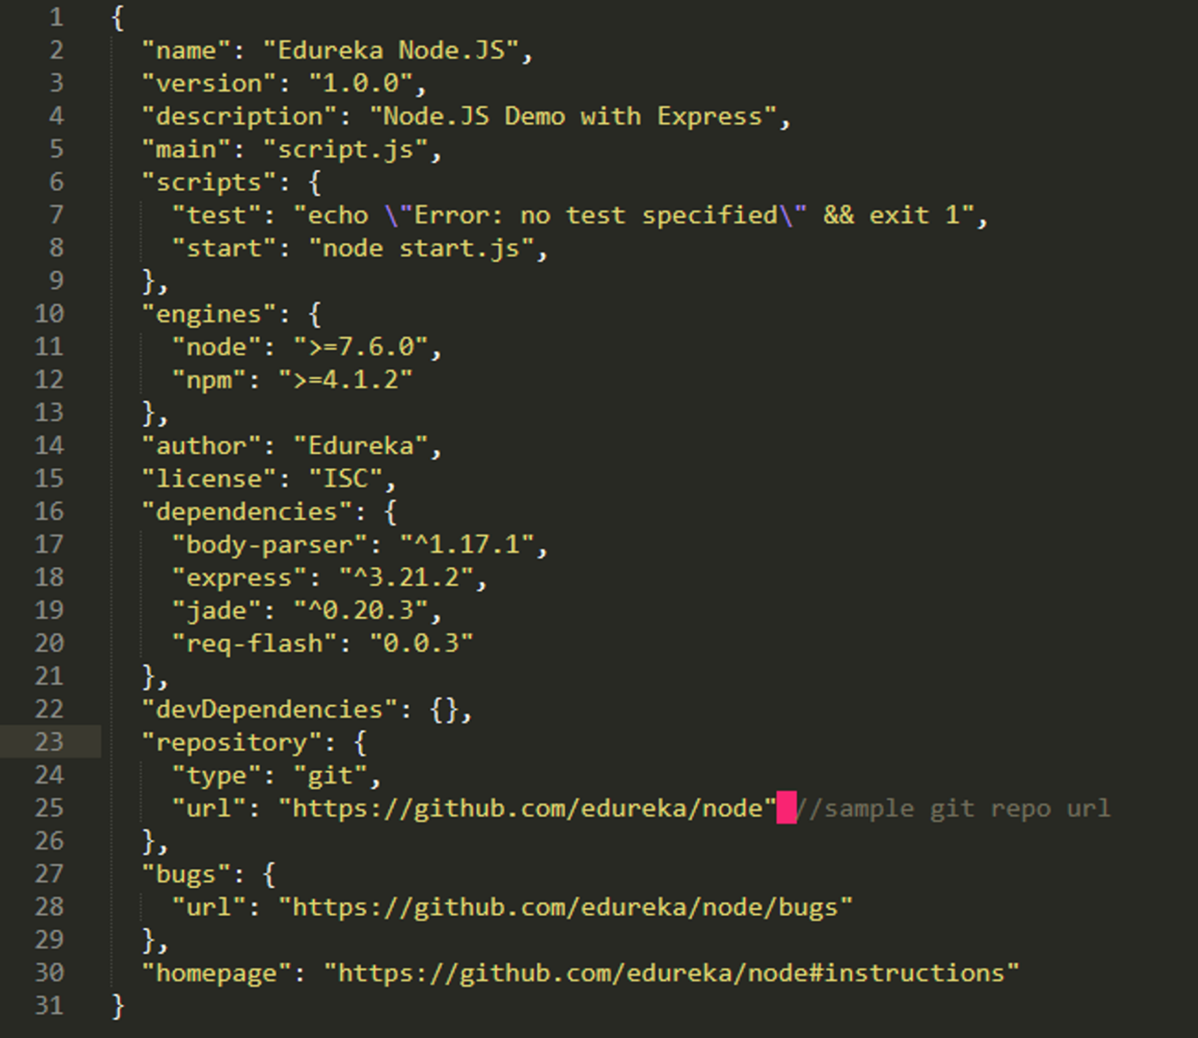

**11. What do you understand by Event-driven programming?**

Event-driven programming is a programming approach that heavily makes use of events for triggering various functions. An event can be anything like a mouse click, key press, etc. When an event occurs, a call back function is executed that is already registered with the element. This approach mainly follows the publish-subscribe pattern. Because of [event-driven programming](https://www.edureka.co/blog/nodejs-tutorial/#events), Node.js is faster when compared to other technologies.

**12. What is an *Event loop* in Node.js and how does it work?**

An event loop in Node.js handles all the asynchronous callbacks in an application. It is one of the most important aspects of Node.js and the reason behind Node.js have non-blocking I/O. Since Node.js is an event-driven language, you can easily attach a listener to an event and then when the event occurs the callback will be executed by the specific listener. Whenever functions like setTimeout, http.get, and fs.readFile are called, Node.js executed the event loop and then proceeds with the further code without waiting for the output. Once the entire operation is finished, Node.js receives the output and then executes the callback function. This is why all the callback functions are placed in a queue in a loop. Once the response is received, they are executed one by one.

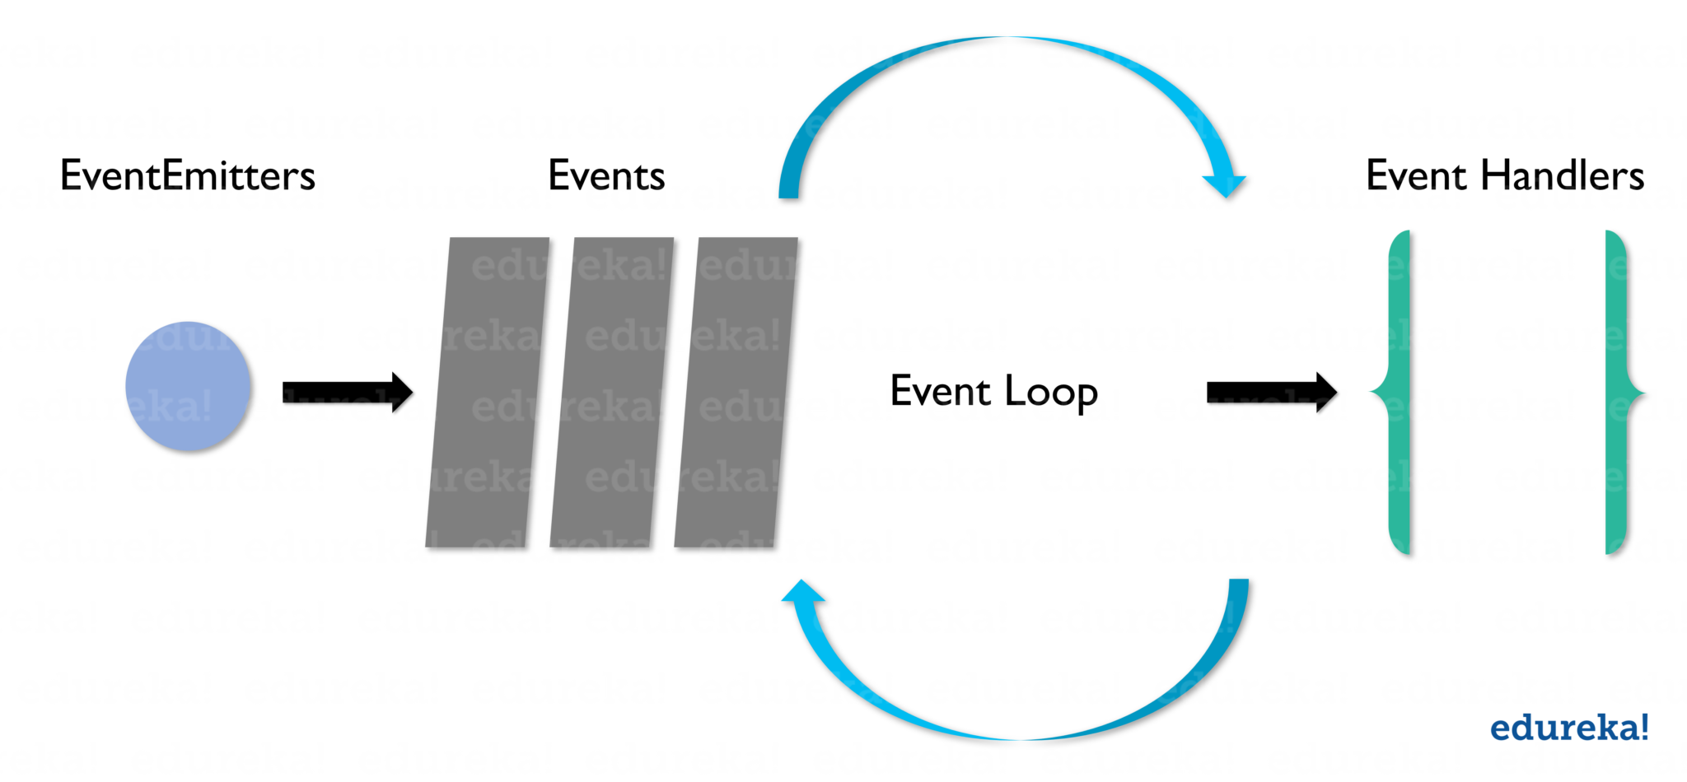

**13. Explain  REPL in the context of Node.js.**

REPL in Node.js stands for **R**ead, **E**val, **P**rint, and **L**oop. It represents a computer environment such as a window console or Unix/Linux shell where any command can be entered and then the system can respond with an output. Node.js comes bundled with a REPL environment by default. REPL can perform the below-listed tasks:

[](https://www.edureka.co/nodejs-certification-training)

[**Node.js Certification Training**](https://www.edureka.co/nodejs-certification-training)

* [*Instructor-led Sessions*](https://www.edureka.co/nodejs-certification-training)
* [*Assignments*](https://www.edureka.co/nodejs-certification-training)
* [*Lifetime Access*](https://www.edureka.co/nodejs-certification-training)
* [*24 x 7 Expert Support*](https://www.edureka.co/nodejs-certification-training)

[Explore Curriculum](https://www.edureka.co/nodejs-certification-training)

* **Read:** Reads the user’s input, parses it into JavaScript data-structure and then stores it in the memory.
* **Eval:** Receives and evaluates the data structure.
* **Print:**Prints the final result.
* **Loop:** Loops the provided command until *CTRL+C* is pressed twice.

**14. List down the tasks which should be done asynchronously using the event loop?**

Below is the list of the tasks which must be done asynchronously using the event loop:

* I/O operations
* Heavy computation
* Anything requiring blocking

**15. List down the steps using which “Control Flow” controls the function calls in Node.js?**

1. Control the order of execution
2. Collect data
3. Limit concurrency
4. Call the next step in the program

**Node.js Interview Questions – Moderate Level**

**16. What do you understand by a test pyramid?**

A test pyramid basically is a diagram that describes the ratio of how many unit tests, integration tests, and end-to-end test are required to be written for the successful development of the project.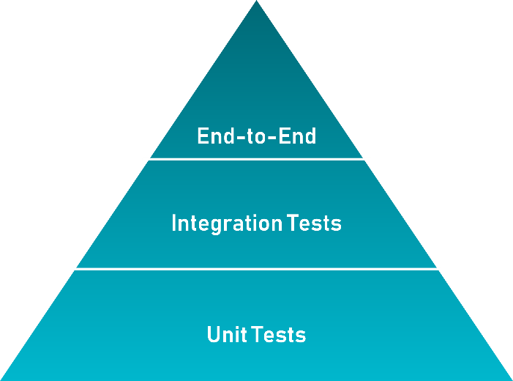

**17. What is an error-first callback in Node.js?**

Error-first callbacks in Node.js are used to pass errors and data. The very first parameter you need to pass to these functions has to be an error object while the other parameters represent the associated data. Thus you can pass the error object for checking if anything is wrong and handle it. In case there is no issue, you can just go ahead and with the subsequent arguments.

|  |  |
| --- | --- |
| 1  2  3  4  5  6  7 | var myPost = new Post({title: 'edureka'});  myPost.save(function(err,myInstance){  if(err){  //handle error and return  }  //go ahead with `myInstance`  }); |

**18. Explain the purpose of module.exports?**

A module in Node.js is used to encapsulate all the related codes into a single unit of code which can be interpreted by shifting all related functions into a single file. For example, suppose you have a file called greet.js that contains the two functions as shown below:

|  |  |
| --- | --- |
| 1  2  3  4  5  6  7 | module.exports = {  greetInHindi: function(){  return "NAMASTE";  },  greetInKorean: function(){  return "ANNYEONGHASEYO";  }}; |

As you can see module.exports provide two functions which can be imported in another file using below code:

|  |  |
| --- | --- |
| 1  2  3 | var eduGreets = require ("./greet.js");  eduGreets.greetInHindi() //NAMASTE  eduGreets.greetInKorean() //ANNYEONGHASEYO |

**19. What do you understand by Reactor Pattern in Node.js?**

**Reactor Pattern** in Node.js is basically a concept of non-blocking I/O operations. This pattern provides a handler that is associated with each I/O operation and as soon as an I/O request is generated, it is then submitted to a *demultiplexer*. This demultiplexer is a notification interface which is capable of handling concurrency in non-blocking I/O mode. It also helps in collecting each and every request in the form of an event and then place each event in a queue. Thus resulting in the generation of the Event Queue. Simultaneously, we have our event loop which iterates the events present in the Event Queue.

**20. What’s the difference between ‘front-end’ and ‘back-end’ development?**

|  |  |
| --- | --- |
| **Front-end Development** | **Back-end Development** |
| 1. Uses mark up and web languages like HTML, CSS, [JavaScript](https://www.edureka.co/blog/what-is-javascript/) | 1. Uses programming and scripting languages like [Python](https://www.edureka.co/blog/python-tutorial/), [Ruby](https://www.edureka.co/blog/ruby-on-rails-tutorial/), Perl, etc. |
| 2. Based on asynchronous requests and AJAX | 2. Based on Server Architecture |
| 3. Better Accessibility | 3. Enhanced Security |
| 4. Used for SEO | 4. Used for Backup |

**21. What are LTS releases of Node.js?**

**LTS**stands **L**ong **T**erm **S**upport version of Node.js that receives all the critical bug fixes along with security updates and performance improvements. These versions are supported for at least 18 months and mainly focus on stability and security. The modifications done to the LTS versions are restricted to the bug fixes, security upgrade, npm, and documentation updates, performance improvement, etc.

**22. List down the major security implementations within Node.js?**

Major security implementations in Node.js are:

1. Authentications
2. Error Handling

**23. What do you understand by callback hell?**

Callback Hell is also known as the Pyramid of Doom. It is a pattern caused by intensively nested callbacks which are unreadable and unwieldy. It typically contains multiple nested callback functions which in turn make the code hard to read and debug. It is caused by improper implementation of the asynchronous logic.

|  |  |
| --- | --- |
| 1  2  3  4  5  6  7  8  9 | async_A(function(){  async_B(function(){  async_C(function(){  async_D(function(){  ....  });  });  });  }); |

**24. Explain libuv.**

Libuv is a multi-platform support library of Node.js which majorly is used for asynchronous I/O. It was primarily developed for Node.js,  with time it is popularly practiced with other systems like as Luvit, pyuv, Julia, etc. Libuv is basically an abstraction around libev/ IOCP depending on the platform, providing users an API based on libev. A few of the important features of libuv are:

* Full-featured event loop backed
* File system events
* Asynchronous file & file system operations
* Asynchronous TCP & UDP sockets
* Child processes

**25. Explain the concept of middleware in Node.js?**

In general, middleware is a function receives the Request and Response objects. In other words, in an application’s request-response cycle these functions have access to various request &  response objects along with the next function of the cycle. The next function of middleware is represented with the help of a variable, usually named next. Most commonly performed tasks by the middleware functions are:

* Execute any type of code
* Update or modify the request and the response objects
* Finish the request-response cycle
* Invoke the next middleware in the stack

**26. Explain the concept of URL module.**

The **URL module** of Node.js provides various utilities for **URL** resolution and parsing. It is a built-in module that helps in splitting up the web address into a readable format:

|  |  |
| --- | --- |
| 1 | var url = require('url'); |

**For example:**

|  |  |
| --- | --- |
| 1  2  3  4  5  6  7  8 | var url = require('url');  var adrs = '<http://localhost:8082/default.htm?year=2019&month=april>';  var q = url.parse(adr, true);  console.log(q.host); //returns 'localhost:8082'  console.log(q.pathname); //returns '/default.htm'  console.log(q.search); //returns '?year=2019 and month=april'  var qdata = q.query; //returns an object: { year: 2019, month: 'april' }  console.log(qdata.month); //returns 'april' |

**27. What do you understand by ESLint?**

ESLint is an open source project initially developed by Nicholas C. Zakas in 2013 which aims to provide a linting utility for JavaScript through a plug. Linters in Node.js are good tools for searching certain bug classes, especially those which are related to the variable scope.

**28. For Node.js, why Google uses V8 engine?**

Google uses V8 as it is a Chrome runtime engine that converts JavaScript code into native machine code. This, in turn, speeds up the application execution and response process and give you a fast running application.

**29. Explain the working of the control flow function.**

In Node.js, the control flow function is basically the code that is executed between the asynchronous function calls. Below are the steps that must be followed for executing it:

1. Firstly, the order of execution must be controlled.
2. Then, the required data need to be collected.
3. Next, the concurrency must be limited.
4. Once done, the next step of the program has to be invoked.

**30. List down the two arguments that async.queue takes as input?**

Below are the two arguments that async.queue takes as input:

1. Task Function
2. Concurrency Value

**31. Differentiate between spawn() and fork() methods in Node.js?**

In Node.js, the spawn() is used to launch a new process with the provided set of commands. This method doesn’t create a new V8 instance and just one copy of the node module is active on the processor. When your child process returns a large amount of data to the Node you can invoke this method.

*Syntax:*

|  |  |
| --- | --- |
| 1 | child_process.spawn(command[, args][, options]) |

Whereas, the fork() in Node.js is a special instance of spawn() that executes a new instance of the V8 engine. This method simply means that multiple workers are running on a single Node code base for various task.

*Syntax:*

|  |  |
| --- | --- |
| 1 | child_process.fork(modulePath[, args][, options]) |

**32. What do you understand by global objects in Node.js?**

In Node.js, Globals are the objects which are global in nature and are available in all the modules of the application. You can use these objects directly in your application, rather than having to include them explicitly. The global objects can be modules, functions, strings, object, etc. Moreover, some of these objects can be in the module scope instead of global scope.

**33. Explain the concept of stub in Node.js.**

In Node.js, stubs are basically the programs or functions that are used for stimulating the module or component behavior. During any test cases, stubs provide the canned answers of the functions.

**34. How assert works in Node.js?**

In Node.js, assert is used to write tests. It only provides feedback only when any of the running test cases fails. This module gives you a set of assertion tests which are then used for testing invariants. It is basically used internally by Node.js but using require(‘assert’) code, it can be used in other applications as well.

|  |  |
| --- | --- |
| 1  2  3  4  5  6 | var assert = require('assert');  function mul(a, b) {  return a * b;  }  var result = mul(1,2);  assert( result === 2, 'one multiplied by two is two'); |

**35. Define the concept of the test pyramid. Explain the process to implement them in terms of HTTP APIs.**

The test**pyramid** is basically a concept that is developed by Mike Cohn. According to this, you should have a higher number of low-level unit **tests** as compared to high-level end-to-end **tests that**running through a GUI.

In terms of HTTP APIs it may be defined as:

* A higher number of low-level unit tests for each model
* Lesser integration tests to test model interactions
* Lesser acceptance tests for testing actual HTTP endpoints

**36. Explain the purpose of ExpressJS package?**

Express.js is a framework built on top of Node.js that facilitates the management of the flow of data between server and routes in the server-side applications.  It is a lightweight and flexible framework that provides a wide range of features required for the web as well as mobile application development. Express.js is developed on the middleware module of Node.js called ***connect***. The connect module further makes use of **http** module to communicate with Node.js. Thus, if you are working with any of the connect based middleware modules, then you can easily integrate with Express.js.

**37. Differentiate between process.nextTick() and setImmediate()?**

In Node.js, process.nextTick() and setImmediate(), both are functions of the Timers module which help in executing the code after a predefined period of time. But these functions differ in their execution. The process.nextTick function waits for the execution of action till the next pass around in the event loop or once the event loop is completed only then it will invoke the callback function. On the other hand, setImmediate() is used to execute a callback method on the next cycle of the event loop which eventually returns it to the event loop in order to execute the I/O operations.

**38. Explain the usage of a buffer class in Node.js?**

Buffer class in Node.js is used for storing the raw data in a similar manner of an array of integers. But it corresponds to a raw memory allocation that is located outside the V8 heap. It is a global class that is easily accessible can be accessed in an application without importing a buffer module. Buffer class is used because pure JavaScript is not compatible with binary data. So, when dealing with TCP streams or the file system, it’s necessary to handle octet streams.

**39. How does Node.js handle the child threads?**

In general, Node.js is a single threaded process and doesn’t expose the child threads or thread management methods. But you can still make use of the child threads using spawn() for some specific asynchronous I/O tasks which execute in the background and don’t usually execute any JS code or hinder with the main event loop in the application. If you still want to use the threading concept in your application you have to include a module called ChildProcess explicitly.

[](https://www.edureka.co/nodejs-certification-training)

[**Node.js Certification Training**](https://www.edureka.co/nodejs-certification-training)

[Weekday / Weekend BatchesSee Batch Details](https://www.edureka.co/nodejs-certification-training)

**40. Explain stream in Node.js along with its various types.**

Streams in Node.js are the collection of data similar to arrays and strings. They are objects using which you can read data from a source or write data to a destination in a continuous manner. It might not be available at once and need not to have fit in the memory. These streams are especially useful for reading and processing a large set of data. In Node.js, there are four fundamental types of streams:

1. *Readable:*Used for reading large chunks of data from the source.
2. *Writeable:* Use for writing large chunks of data to the destination.
3. *Duplex:*Used for both the functions; read and write.
4. *Transform:*It is a duplex stream that is used for modifying the data.

**Node.js Interview Questions – Advanced Level**

**41. What is the use of NODE_ENV?**

If the project is in the production stage, Node.js promotes the convention of making use of NODE_ENV variable to flag it. This helps in taking better judgment during the development of the projects. Also, when you set your NODE_ENV to production, your application tends to perform 3 times faster.

**42. Differentiate between readFile vs createReadStream in Node.js?**

Node.js provides two ways to read and execute files which are using readFile and CreateStream. readFile() is a fully buffered process which returns the response only when the complete file is pushed into the buffer and is read. It is a memory intensive process and in case of large files, the processing can be very slow. Whereas createReadStream is a partially buffered which treats the entire process as an event series. The entire file is split into chunks which are then processed and sent back as a response one by one. Once done, they are finally removed from the buffer. Unlike readFile, createReadStream is really effective for the processing of the large files.

**43. List down the various timing features of Node.js.**

Node.js provides a Timers module which contains various functions for executing the code after a specified period of time. Below I have listed down the various functions provided by this module:

* **setTimeout/clearTimeout** – Used to schedule code execution after a designated amount of milliseconds
* **setInterval/clearInterval** – Used to execute a block of code multiple times
* **setImmediate/clearImmediate** – Used to execute code at the end of the current event loop cycle
* **process.nextTick** – Used to schedule a callback function that needs to be invoked in the next iteration of the Event Loop

**44. Explain the concept of Punycode in Node.js?**

In Node.js, Punycode is an encoding syntax that is used for converting Unicode (UTF-8) string of characters into a basic ASCII string of characters. It is important as the hostnames can only understand the ASCII characters. Thus, Node.js version 0.6.2 onwards, it was bundled up with the default Node package. If you want to use it with any previous versions, you can easily do that by using the following code:

Syntax:

|  |  |
| --- | --- |
| 1 | punycode = require('punycode'); |

**45. Differentiate between Node.js vs Ajax?**

The most basic difference between Node.js and Ajax that, Node.js is a server-side JavaScript whereas Ajax is a client-side technology. In simpler terms, Ajax is mostly used for updating or modifying the webpage contents without having to refresh it. On the other hand, Node.js is required to develop the server software that are typically executed by the servers instead of the web browsers.

**46. Does Node.js provide any Debugger?**

Node.js do provide a simple TCP based protocol and debugging client that comes built-in. In order to debug your JavaScript file, you can use the below debug argument followed by **js** file name that you want to debug.

*Syntax:*

|  |  |
| --- | --- |
| 1 | node debug [script.js | -e "script" | <host> : <port> ] |

**47. Describe the exit codes of Node.js.**

In Node.js, exit codes are a set of specific codes which are used for finishing a specific process. These processes can include the global object as well. Below are some of the exit codes used in Node.js:

* Uncaught fatal exception
* Unused
* Fatal Error
* Internal Exception handler Run-time failure
* Internal JavaScript Evaluation Failure

**48. What do you understand by an Event Emitter in Node.js?**

EventEmitter is a Node.js class that includes all the objects that are capable of emitting events. These objects contain an eventEmitter.on() function through which more than one function can be attached to the named events that are emitted by the object. Whenever an EventEmitter object throws an event, all the attached functions to that specific event are invoked synchronously. Below code shows how to us the EventEmitter in your application:

|  |  |
| --- | --- |
| 1  2  3  4  5  6  7 | const EventEmitter = require('events');  class MyEmitter extends EventEmitter { }  const myEmitter = new MyEmitter();  myEmitter.on('event', () => {  console.log('an event occurred!');  });  myEmitter.emit('event'); |

**49. Is cryptography supported in Node.js?**

Yes, Node.js does support cryptography through a module called Crypto. This module provides various cryptographic functionalities like cipher, decipher, sign and verify functions, a set of wrappers for open SSL’s hash HMAC etc. For example:

*Syntax:*

|  |  |
| --- | --- |
| 1  2  3  4 | const crypto = require'crypto');  const secret = 'akerude';  const hash = crypto.createHmac('swaEdu', secret).update('Welcome to Edureka').digest('hex');  console.log(hash); |

**50. Explain the reason as to why Express ‘app’ and ‘server’ must be kept separate.**

Express ‘app’ and ‘server’ must be kept separate as by doing this, you will be separating the API declaration from the network related configuration which benefits in the below listed ways:

* It allows testing the API in-process without having to perform the network calls
* Faster testing execution
* Getting wider coverage metrics of the code
* Allows deploying the same API under flexible and different network conditions
* Better separation of concerns and cleaner code

API declaration should reside in app.js:

|  |  |
| --- | --- |
| 1  2  3  4 | var app = express();  app.use(bodyParser.json());  app.use("/api/events", events.API);  app.use("/api/forms", forms); |

Server network declaration should reside in /bin/www:

|  |  |
| --- | --- |
| 1  2  3  4  5  6  7 | var app = require('../app');  var http = require('http');  //Get port from environment and store in Express  var port = normalizePort(process.env.PORT || '8000');  app.set('port', port);  //Create HTTP server.  var server = http.createServer(app); |

With this, we come to an end of this Node.js Interview Questions article. I hope you found it informative and it helped in adding up to your knowledge. If you want to cover the fundamentals of Node.js in more depth, you can refer to my [Node.js Tutorial](https://www.edureka.co/blog/nodejs-tutorial/) article.